INTRA-DEPARTMENT PROJECT-I REPORT

**AUTOMATIC STREET LIGHT CONTROLLER**

**Submitted**

By

|  |  |  |
| --- | --- | --- |
| Nitish Kumar 201FA04433 | Monu Kumar  201FA05092 | |
| Dipu Kumar P. Vaseema  201FA04432 201FA05071 | | |

Under the guidance of

Dr. N. Ananda Rao



**DEPARTMENT OF ELECTRONICS & COMMUNCATION ENGINEERING**

**VIGNAN'S FOUNDATION FOR SCIENCE, TECHNOLOGY AND RESEARCH Deemed to be UNIVERSITY**

**Vadlamudi, Guntur**

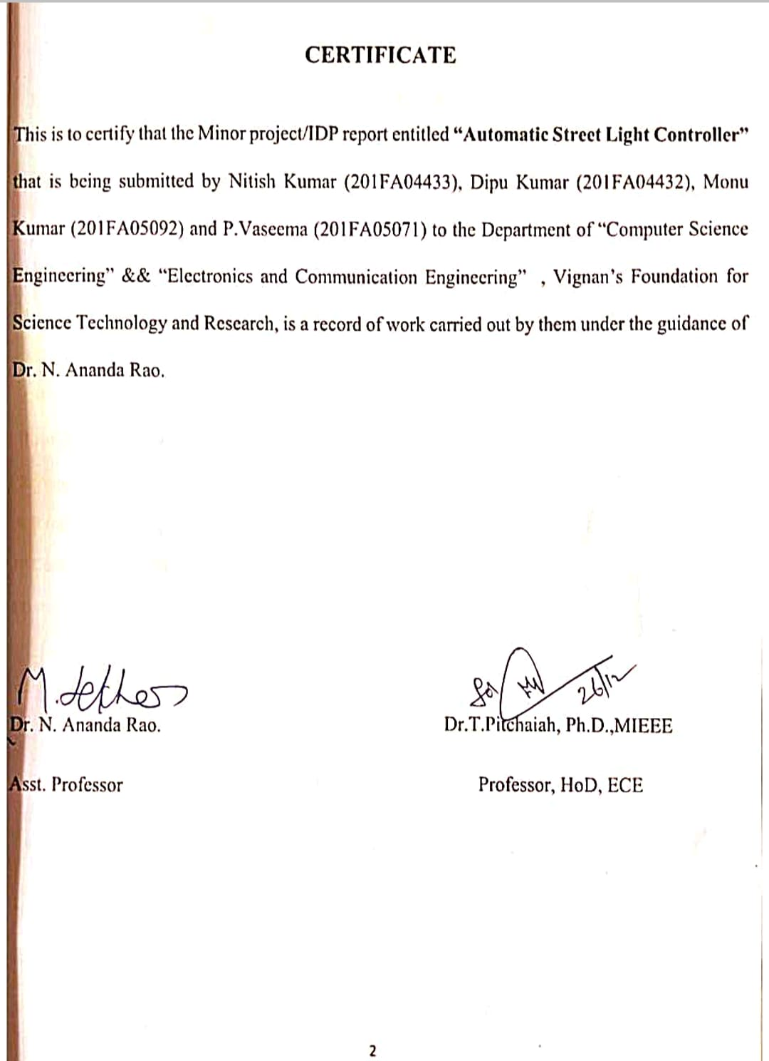

# TABLE OF CONTENTS

1. Abstract……………………………….…………………………………………………………….4

2.Objective………………………………………..………………………………………………..…5

3.Introduction……………………………………………..………………………………………..…6

4. Circuit Diagram…………………………………………………..………………...……………...7

5.Components Required………………………………………………………………..…………….8

6.Working……………………………………….………………………………………………......12

7.Advantages and Disadvantage…………………………………………………………………….13

8. Application………………………………………………………………………………………..14

9. Result……………………………………………………...………………………………...…….15

10.Conclusion and future scope………………………………………………………………………16

11. Reference………………………………………………………………………………………….17

1. **ABSTRACT**

The main consideration in the present field technologies are Automation, Power consumption and cost effectiveness. Automation is intended to reduce man power with the help of intelligent systems.

Power saving is the main consideration forever as the source of the power are getting diminished due to various reasons. As we all know that energy consumption has been increasing day by day so, to overcome these consequences we are using Ardino devices.

This project proposes a modal for modifying street light illumination by using sensors at minimum electrical energy consumption. When presence is detected, all surrounding street lights glow at their brightest mode, else they stay in the dim mode.

LED bulbs shall be implemented as they are better than conventional incandescent bulbs in every way. This shall reduce heat emissions, power consumption, maintenance and replacement costs and carbon dioxide emissions.

Also, a demonstration with a real-time proto type model involving costs and implementation procedure has been developed using internet of things to visualize the real time updates of street processing and notifying the changes occur.

1. **OBJECTIVE**

The main objective of this project is to implement an Embedded based Automatic Street Light Controller System. As the traffic decreases slowly during late-night hours, the intensity gets reduced progressively till morning to save energy and thus, the street lights switch on at the dusk and then switch off at the dawn, automatically. The process repeats every day. White Light Emitting Diodes (LED) replaces conventional HID lamps in street lighting system to include dimming feature. The intensity is not possible to be controlled by the high intensity discharge (HID) lamp which is generally used in urban street lights. LED lights are the future of lighting because of their low energy consumption and long life. LED lights are fast replacing conventional lights because intensity control is possible by the pulse width modulation. This proposed system uses an Arduino board. Strings of LED are interfaced to the Arduino board. A programmed Arduino board is engaged to provide different intensities at different times of the night. This project is enhanced by integrating the LDR to follow the switching operation precisely and IOT to display the status of street on web browser and help in controlling it.

1. **INTRODUCTION**

The street lighting is one of the largest energy expenses for a city. An intelligent street lighting system can cut municipal street lighting costs as much as 50% - 70%. The present system is like the lights will be switched on in the evening before the sun sets and they are switched off the next day morning after there is sufficient light on the outside. But the actual timing for these lights to be switched on are when there is absolute darkness. With this, the power will be wasted up to some extent. In sunny and rainy days, ON and OFF time differ discernibly which is one of the significant hindrances of the present street lights systems. Also the manual operation of the lighting system is completely eliminated.

The energy consumption in entire world is increasing at the fastest rates due to population growth and economic development and the availability of energy sources remains woefully constrained. Resource augmentation and growth in energy supply has not kept pace with increasing demand and, therefore, continues to face serious energy shortages. Streetlights are an integral part of any developing locality. They are present on all major roadways and in the suburbs too. Every day, streetlights are powered from sunset to sunrise at full strength, even when there is no one around.

On a global scale, millions of dollars are spent each day on these street lights to provide the required electrical energy. The maintenance and replacement costs of conventional incandescent bulbs are immense. They consume a lot of electric power to function and their heat emissions are also quite high.

All of this contributes to greater demand of electricity production and consequently, more carbon dioxide emissions from powerhouses. So, along with unnecessary light pollution, this practice causes damage to our planet too. The main aim of the project is to provide an “Automatic Street Lightning System” powered with solar energy during night time. We use the word “smart” because the system not only provide power to the street lights but also helps in detecting the direction of movement of the pedestrian and helps him by means of illuminating the path of movement till the near next street light. By integrating the entire street lights with Smart street light system it is possible to systematically help the pedestrian to reach the destination in the remote rural areas which are facing serious electric power supply problem.

The same system can also be used in metropolitan cities as well. A simple and effective solution to this would be dimming the lights during off peak hours. Whenever presence is detected, the lights around it will glow at the normal (bright) mode. This would save a lot of energy and also reduce cost of operation of the streetlights.

1. **CIRCUIT DIAGRAM**

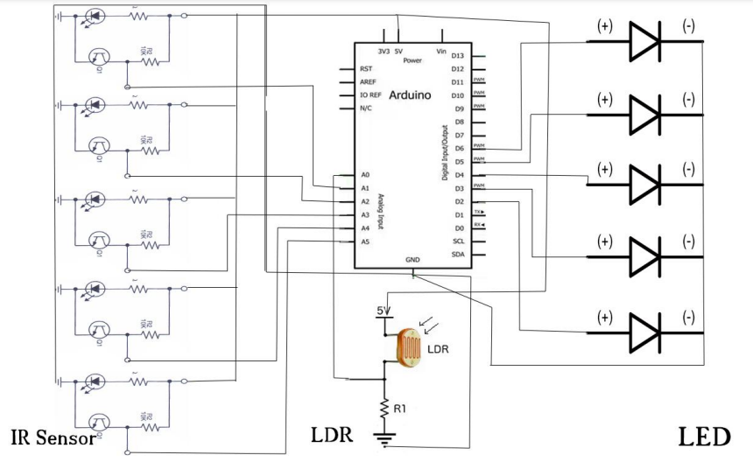

1. **COMPONENTS REQUIRED**
   1. Breadboard
   2. LED - 10
   3. LDR - 1
   4. IR Sensor – 10
   5. Jumper Wires
   6. Arduino Mega (Atmel mega 2560)

**DESCRIPTION OF COMPONENTS:**

**1. Bread Borad**

A breadboard is a construction base for prototyping of electronics.This makes it easy to use for creating temporary prototypes and experimenting with circuit design.

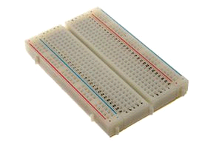

1. **LED**

A light-emittingdiode (LED) is a two-lead semiconductor light source. It is a p–n junction diode that emits light when activated. When a suitable current is applied to the leads, electrons are able to recombine with electron holes within the device, releasing energy in the form of photons. This effect is called electroluminescence.

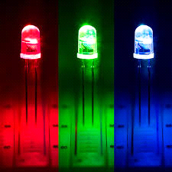

**3.LDR Sensors**

  An LDR is a component that has a (variable) resistance that changes with the light intensity that falls upon it. This allows them to be used in light sensing circuits. Light Dependent Resistors (LDR) are also called photoresistors.

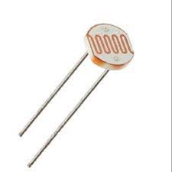

**4.Infrared Sensors**

An infrared sensor (IR sensor) is a radiation-sensitive optoelectronic component with a spectral sensitivity in the infrared wavelength range 780 nm to 50µm. IR sensors are now widely used in motion detectors, which are used in building services to switch on lamps or in alarm systems to detect unwelcome guests.

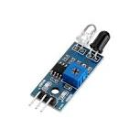

**5.Jumper Wires**

Connecting wires allows an electrical current to travel from one point on a circuit to another, because electricity needs a medium through which to move. In the case of computers, wires are embedded into circuit boards, carrying pulses of electricity that are interpreted as binary signals of zeros and ones.

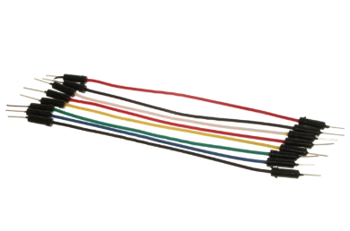

**6.Arduino Mega(2560)**

The **Arduino Mega 2560** is a microcontroller board based on the ATmega2560. It has 54 digital input/output pins (of which 15 can be used as PWM outputs), 16 analog inputs, 4 UARTs (hardware serial ports), a 16 MHz crystal oscillator, a USB connection, a power jack, an ICSP header, and a reset button. It contains everything needed to support the microcontroller; simply connect it to a computer with a USB cable or power it with a AC-to-DC adapter or battery to get started.  The Mega 2560 board is compatible with most shields designed for the Uno and the former boards.

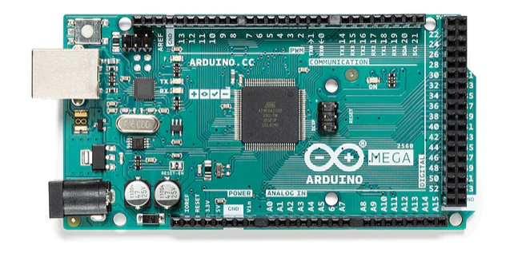

1. **WORKING**
2. Outputs of LDR pin is connected to A10 (analog) port of Arduino mega board.
3. Connect all outputs of the IR sensors to port number A0, A1, A2, A3, A4, A5, A6, A7, A8, A9, A10 respectively (analog) which is input signal to Arduino.
4. Connect the ground of all the IR sensors to GND port.

1. The outputs signals from LED are connected to port number 2, 3, 4, 5, 6, 7, 8, 9, 10, 11 respectively in I/O port.
2. Again connected all the negative terminal of LED’s to the GND port.
3. Power is passed to the Arduino(7-12V).
4. **ADVANTAGES AND DISADVANTAGES**

**ADVANTAGES**

* The street light control circuit can be used in normal roads, highways, express ways etc.
* The project can also be used in parking areas of malls, hotels, industrial lighting, etc.
* If the lighting system implements all LED lights, the cost of the maintenance can be reduced as the life span and durability of LEDs is higher than Neon based lights which are normally used as street lights.
* As the lights are automatically turned ON or OFF, huge amount of energy can be saved.
* This system less costly, less installation and maintenance cost and more efficient as compared to the others system.

**DISADVANTAGES**

* This system can be used for only one-way traffic. A highway might be covered by this system on dual system installation on both side.
* The system does not have any automatic fault detector.
* Pole damage detection with the addition of suitable sensor can be implemented.

1. **APPLICATIONS**

* The street light control circuit can be used in normal roads, highways, express ways etc.
* The project can also be used in parking areas of malls, hotels, industrial lighting, etc.
* If the lighting system implements all LED lights, the cost of the maintenance can be reduced as the life span and durability of LEDs is higher than Neon based lights which are normally used as street lights.
* As the lights are automatically turned ON or OFF, huge amount of energy can be saved.
* This system less costly, less installation and maintenance cost and more efficient as compared to the others system.

1. **RESULT**

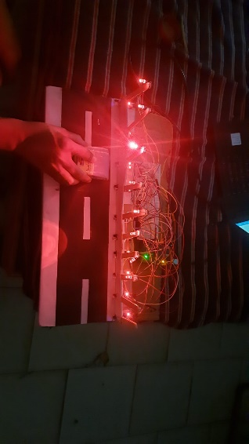

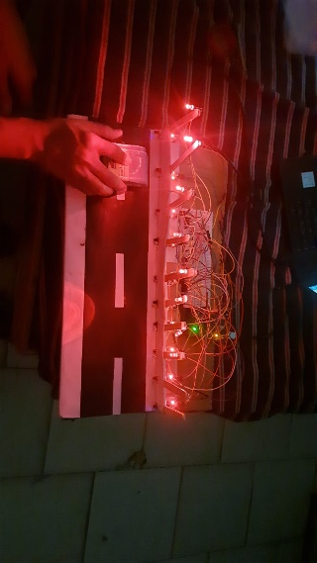

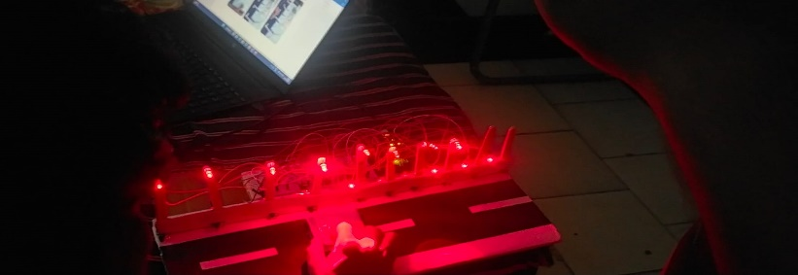

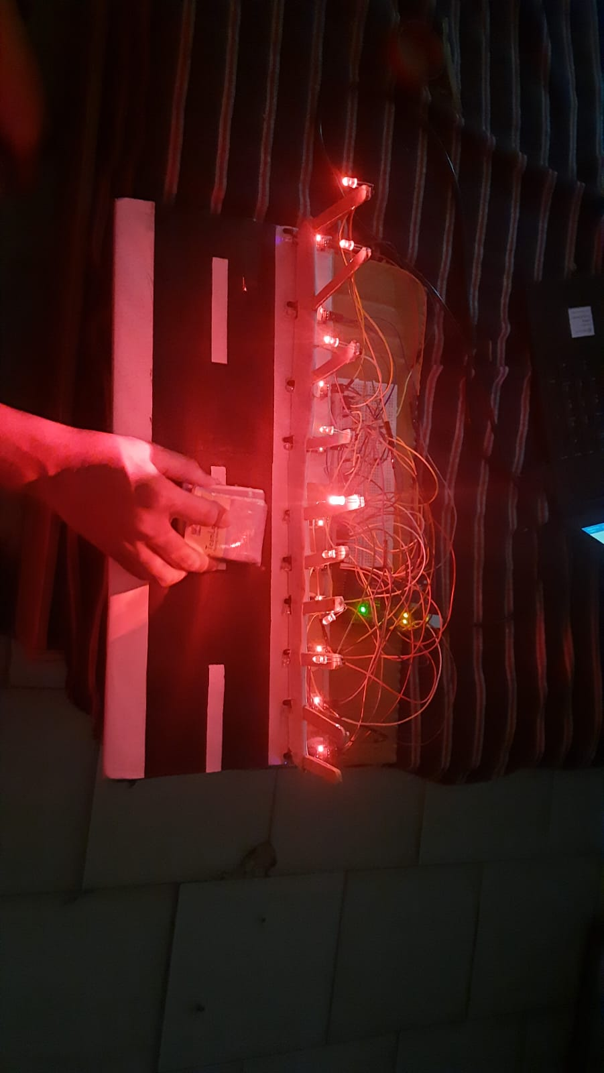

**10. CONCLUSION AND FUTURE SCOPE**

Using this smart project, we can also estimate the speed of the vehicle, recognizing the number plate, recognizing the accidents took place on roads etc. This Smart Street light project not only helps in rural areas but also beneficial in urban areas too. As we are moving towards more advancement we require more power so use of renewable resources is useful and advantageous.

With this project, we can even add smart parking of vehicle and it is even useful for driverless cars. With the advances in technology and good resource planning the cost of the project can be cut down and also with the use of good equipment the maintenance can also be reduced in terms of periodic checks. The LEDs have long life, emit cool light, donor have any toxic material and can be used for fast switching. For these reasons our project presents far more advantages which can over shadow the present limitations. Keeping in view the long term benefits and the initial cost would never be a problem as the investment return time is very less.

The project has scope in various other applications like for providing lighting in industries, campuses and parking lots of huge shopping malls. This can also be used for surveillance in corporate campuses and industries. This project “IoT Based Smart Intelligent Lighting System for Smart City “is a cost effective, practical, eco-friendly and the safest way to save energy and this system the light status information can be accessed from anytime and anywhere.

It clearly tackles the two problems that world is facing today, saving of energy and also disposal of incandescent lamps, very efficiently.

1. **Reference**

[1]. http://opensourceecology.org/wiki/Automation

[2].S. Suganya, R. Sinduja, T. Sowmiya& S. Senthilkumar, Street light glow on detecting vehicle movement using sensor

[3]. K.Santha Sheela,S.Padmadevi, Survey on Street Lighting System Based On Vehicle Movements

[4]. Srikanth M, Sudhakar K N,ZigBee Based Remote Control Automatic Street Light System

[5]. M.Abhishek, Syed ajram shah, K.Chetan, K,Arun Kumar, Design and implementation of traffic flow based street light control system with effective utilization of solar energy, International journal of Science Engineering and Advance Technology, IJSEAT, Vol 3, Issue 9, September -2015

[6]. C.Bhuvaneshwari, R.Rajeswari, C.Kalaiarasan, Analysis of Solar energy based street light with auto tracking system, International Journal of Advanced Research in Electrical, Electronics and Instrumentation Engineering, Vol 2, Issue 7, July 2013

[7]. Steve Chadwick,“Street Light Monitoring – a Practical Solution magazine” November/December 2002

[8]. “Intelligent Street Lighting System Using Gsm” International Journal of Engineering Science Invention ISSN (Online): 2319 – 6734.